

**Sixth Annual Symposium on Bedside Ultrasound in the ICU**

**Saturday, September 14, 2019**

**CONFERENCE SPONSORS**

* Oklahoma Thoracic Society
* The University of Oklahoma Health Sciences Center – Pulmonary, Critical Care & Sleep Medicine Section

**COURSE OBJECTIVES**

Following this learning activity, participants will be able to:

* Demonstrate an understanding of ultrasound physics.
* Demonstrate proper techniques to perform a focused cardiac and lung ultrasonography.
* Recognize the normal sonographic appearance of lower extremity vasculature.
* Recognize common abnormalities of the heart, lung, pleura and vasculature.

**TARGET AUDIENCE**

This course is geared toward pulmonary and critical care fellows, internal medicine and surgery residents, practicing physicians, including pulmonologists, intensivists, hospitalists, and family medicine.

**LOCATION**

Andrews Academic Tower, Level 1, Conference Rooms A, B & C

800 Stanton L. Young, Oklahoma City, OK 73104

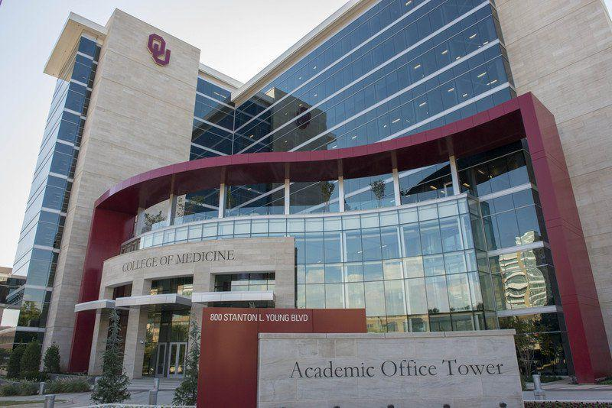**COURSE DIRECTOR**

Houssein Youness, MD, FCCP

**FACULTY**

|  |  |
| --- | --- |
|  | **Tony Abdo, MD:** Assistant Professor of Medicine, University of Oklahoma Health Sciences Center; Pulmonary and Critical Care Medicine |
|  | **Jason S. Lees, MD:** Associate Professor of Surgery, University of Oklahoma Health Sciences Center; Surgical Critical Care |
|  | **Federico Silva Palacios, MD:** Assistant Professor of Medicine, University of Oklahoma Health Sciences Center; Vascular Medicine |
|  | **Becky Pennington, RDCS:** Registered Echocardiography Technician, Oklahoma City VA |
|  | **Kevin Proud, MD, FCCP:** Assistant Professor, UT Health San Antonio & South Texas Veterans Health Care System; Pulmonary and Critical Care Medicine |
|  | **Houssein Youness, MD, FCCP:** Associate Professor of Medicine, University of Oklahoma Health Sciences Center; Pulmonary and Critical Care Medicine |

|  |  |  |
| --- | --- | --- |
| Symposium on Bedside Ultrasound in the ICU  September 14, 2019 | | |
| **TIME** | **TITLE** | **FACULTY** |
| 8:00- 8:30 AM | **Principles of Ultrasound Imaging** | *Tony Abdo, MD* |
| 8:30- 9:00 AM | **Echocardiographic Views** | *Houssein Youness, MD, FCCP* |
| 9:00-10:00 AM | **Ultrasound of the Vascular System** | *Federico Silva Palacios, MD* |
| 10:00-10:20 AM | **Coffee Break** | |
| 10:20-11:00 AM | **Performing and interpreting the ultrasound examination of the lungs and the pleura** | *Kevin C. Proud, MD, FCCP* |
| 11:00-11:30 AM | **Ultrasound for Clinical Decision Making in the ICU** | *Houssein Youness MD, FCCP* |
|  | **Case Studies:** | |
| 11:30-11:45 AM | **Lung Cases** | *Tony Abdo, MD* |
| 11:45-12:00 PM | **Echo Cases** | *Houssein Youness, MD FCCP* |
| 12:00-12:30 PM | Lunch (Provided with course registration) |  |
| 12:30- 1:00 PM | **Interactive Ultrasound Cases** | Houssein Youness, MD FCCP |
| 1:00- 1:30 | **Ultrasound of the Abdomen and the FAST exam** | Jason Lees, MD |
| 1:30- 4:00PM | **Practical Scanning Workshop** | |
|  | **Lung Station (20 min)**  **Cardiac Station 1 (20 min)**  **Cardiac Station 2 (20 min)**  **Focused Protocol (20 min)**  **Vascular Station (20 min)**  **Sono-Sim Station (20 min)** | *Kevin Proud, MD, FCCP*  *Tony Abdo, MD*  *Becky Pennington, RDCS*  *Houssein Youness, MD*  *Federico Silva Palacios, MD* |

**Sixth Annual Symposium on Bedside Ultrasound in the ICU**

**Saturday, September 14, 2019**

**Registration**

Please submit your registration to[Delisa-McKinzie@ouhsc.edu](mailto:Delisa-McKinzie@ouhsc.edu) or 405.271.5892 as soon as possible.

***Please print***

Name (First, Middle, Last): _______________________________________________________________

Degree: ________________ Specialty: _____________________________________________________

Profession:  Attending Physician  Resident  Fellow  Respiratory Therapist  Scientist

Organization: __________________________________________________________________________

Present position: _______________________________________________________________________

Office Address: ________________________________________________________________________

City: ____________________________________________ State: __________ Zip: _____________

Work Phone: _____________________ Cell: _____________________ Fax: _____________________

Area of Interest: _______________________________________________________________________

Email Address: ________________________________________________________________________

**Contact information:**

Oklahoma Thoracic Society

Attention: Delisa McKinzie

Pulmonary, Critical Care & Sleep Medicine

Andrews Academic Tower, Suite 8400

800 Stanton L. Young

Oklahoma City, OK 73104

405.271.6173/ On-campus ext: 46247

**CME:**

No CME credit will be offered

**Registration Fees:**

This course is free for providers interested in learning bedside ultrasound. Bring your enthusiasm with you!